***Fin***Online Fruit Vendor

Project Proposal overview

This project is based on Online Fruits Vendor. In this ASP.net project there one secure for Admin can add, edit, delete and access details of the information . Admin can also edit, delete and access Sales and Buyers Data. Moreover, admin can delete Viewed Messages of Contacts.

Project goal

The main goal of this project is to setup a web application of fruit online vendor using Asp.Net. The name of this web application will be “online Fruit Vendor” In this application there is admin. Admin can manage information by adding, editing, deleting and checking details. Customers can contact through contact page and admin can view that contacts.

|  |  |
| --- | --- |
| Deliverable | Description |
| Project Planning | All Details and information about the project |
| Project Coding | Testing based on marking coding |
| Implementation Details | Different query implementation for creating deleting the data |
| Documentation | All Information about the project is stored here |

Login System

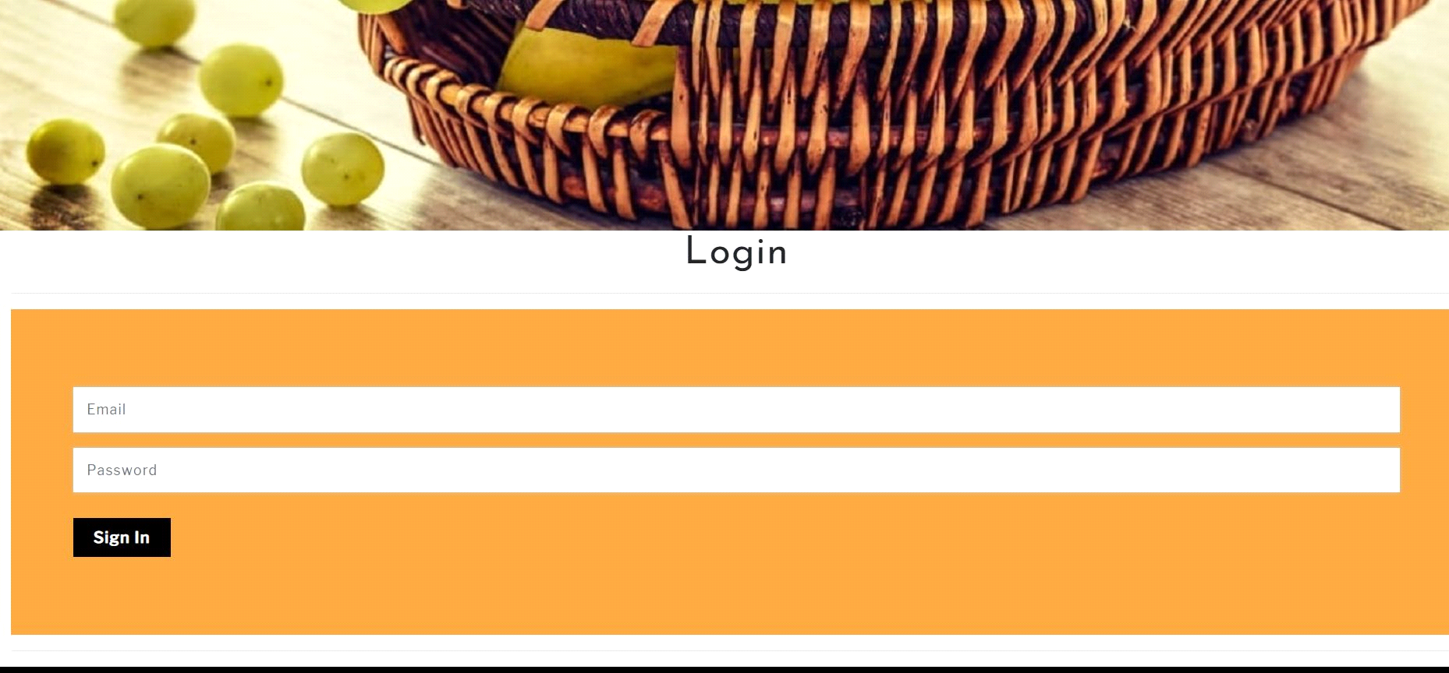

|  |  |
| --- | --- |
| Username | Password |
| [admin@admin.com](mailto:admin@admin.com) | admin |

Admin Login is very important part of the project it allows admin to enter into panel where admin can add, update and delete the record of employee, stock, sale, purchase and contact information

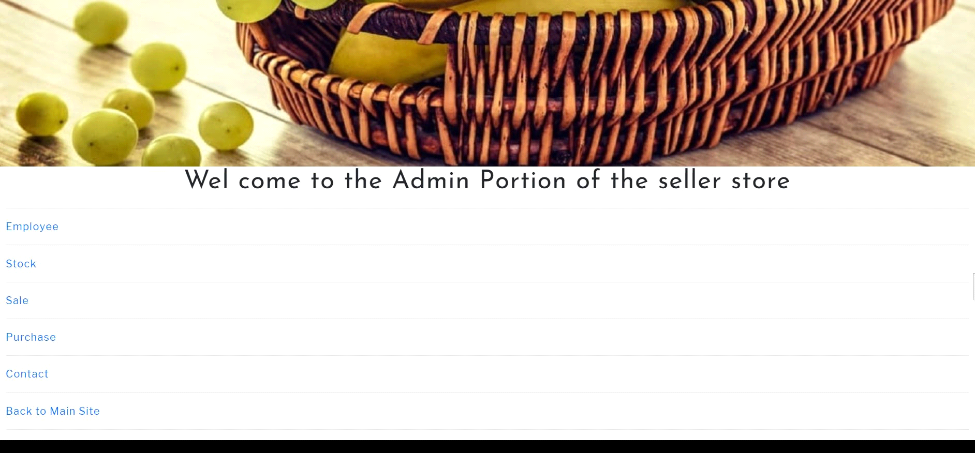

Testing Sales Record

Without inserting Record

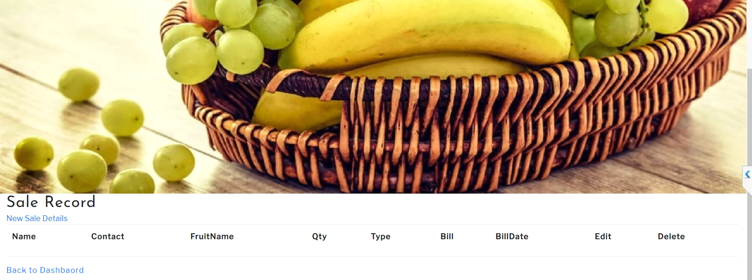

After Inserting Data

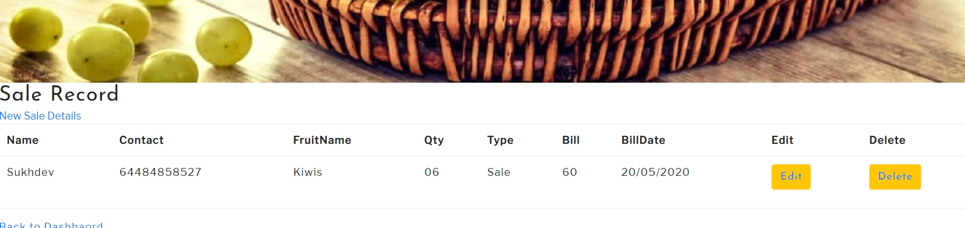

Updating sales record

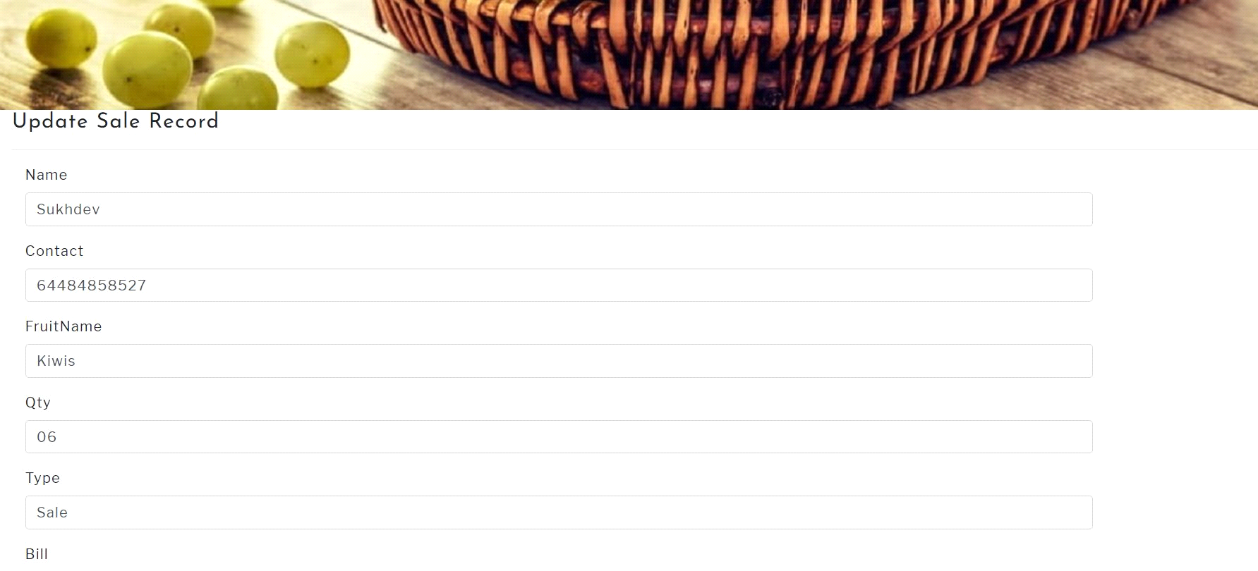

After updating sales record

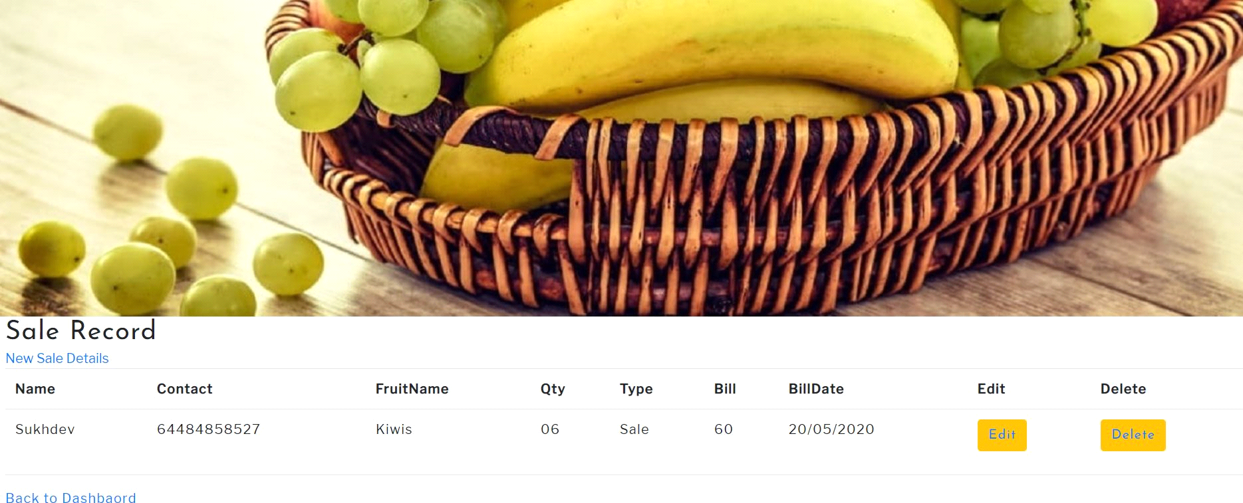

Customer can contact by filling below details

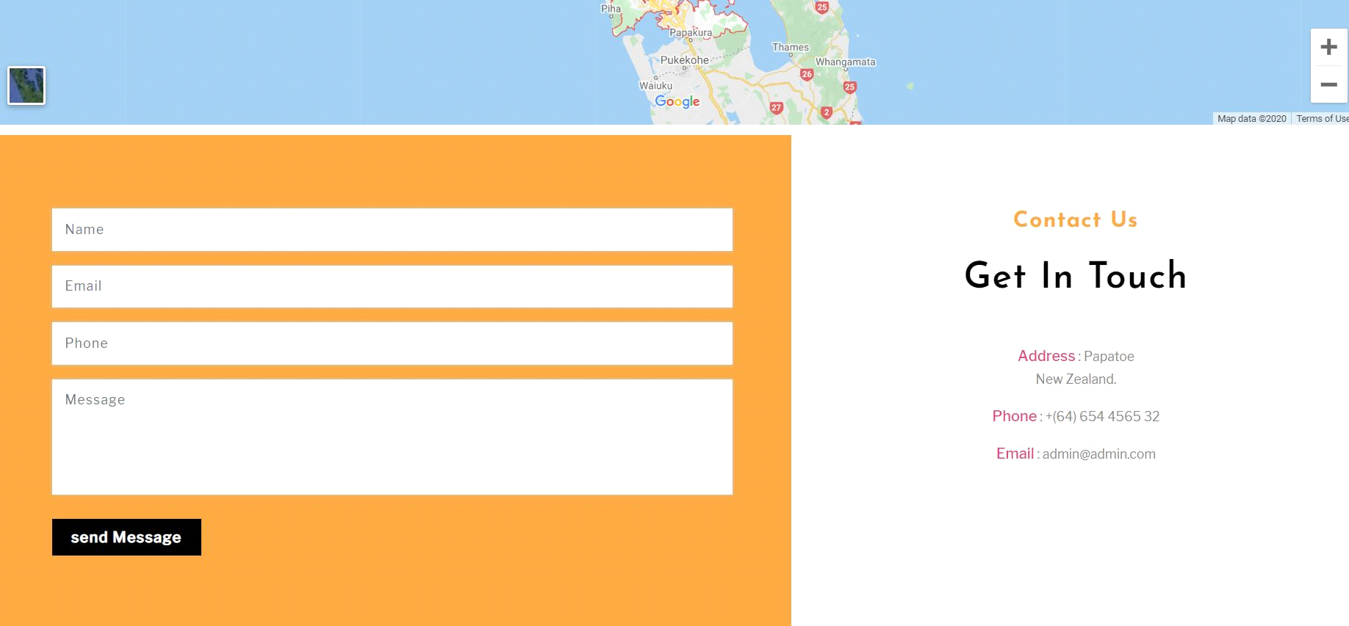

After contacting customer will see the following message



Admin after logging in can see the persons who have contacted them

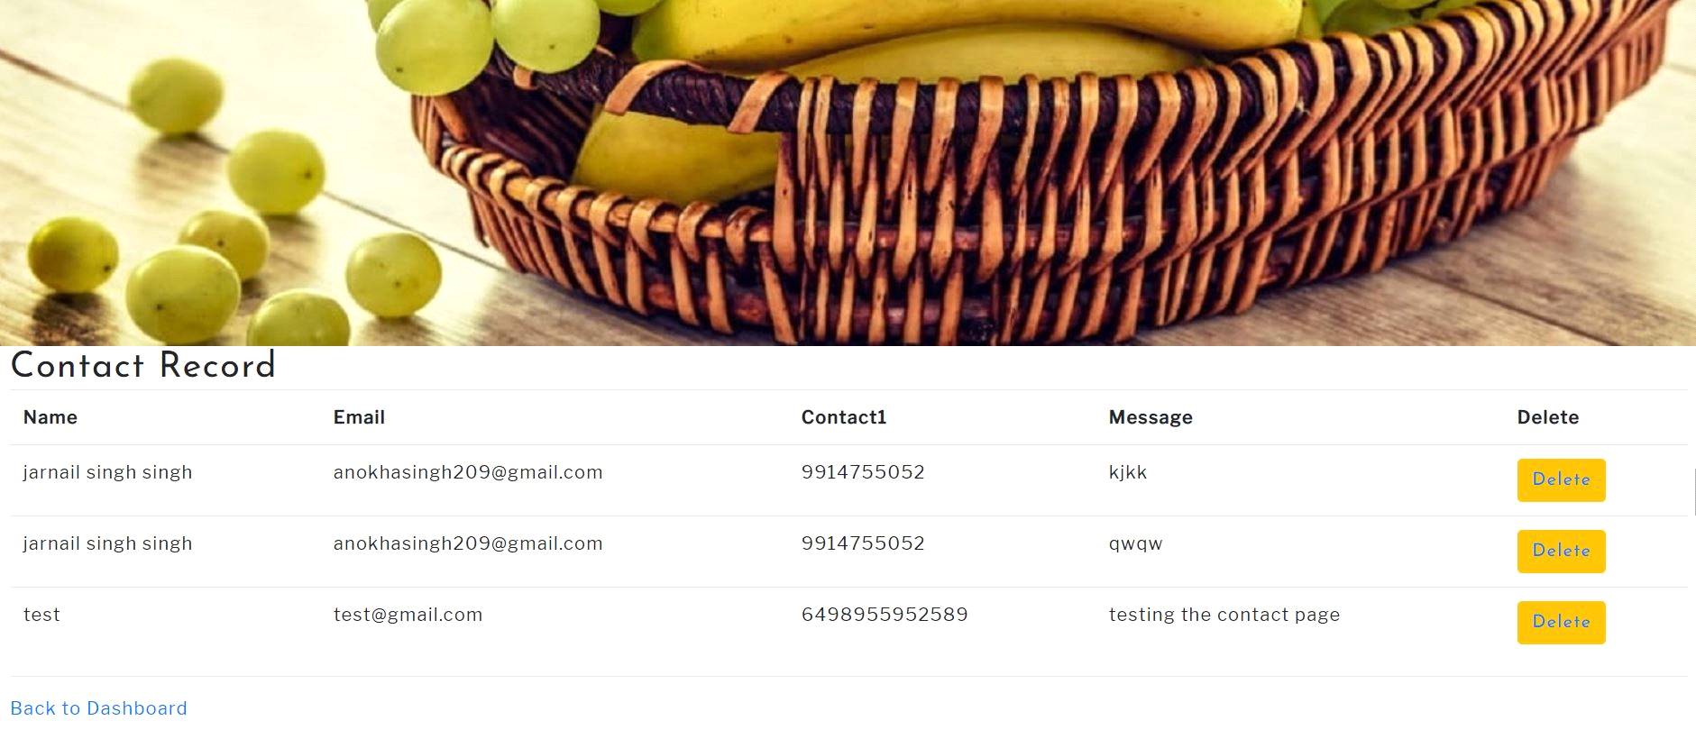

Employee data is entered and can be edited and deleted after clicking on the below buttons

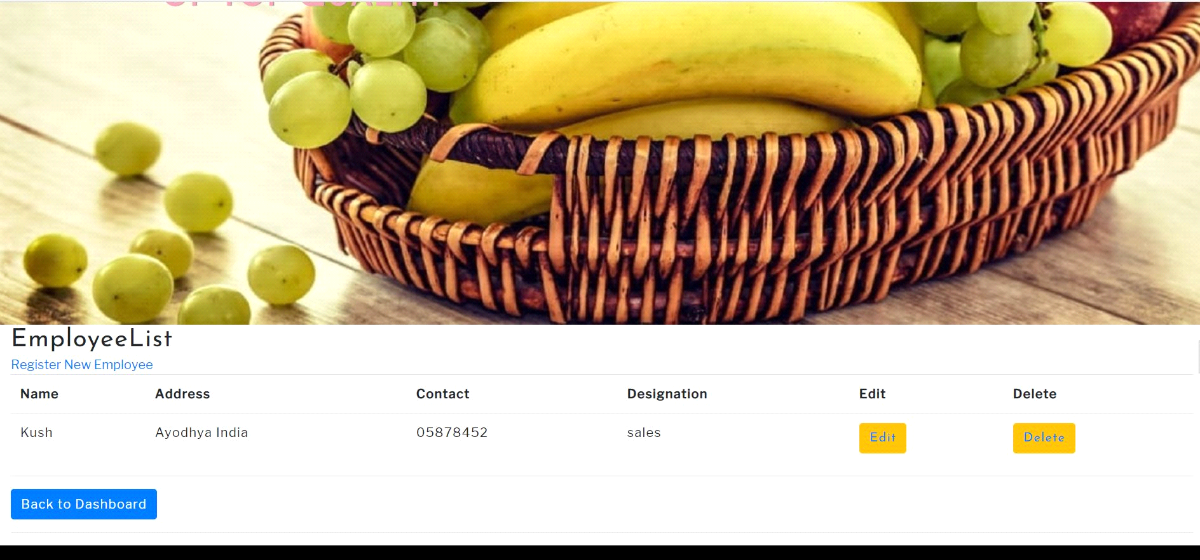

Purchase record is entered

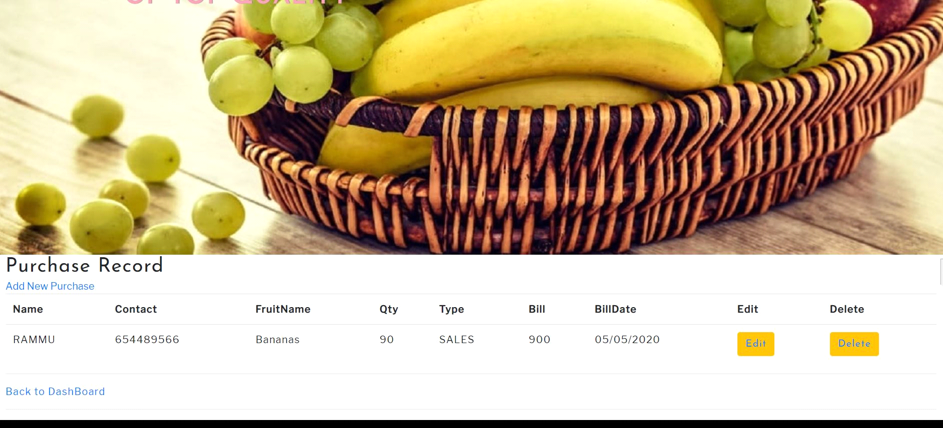

Stock Record is entered

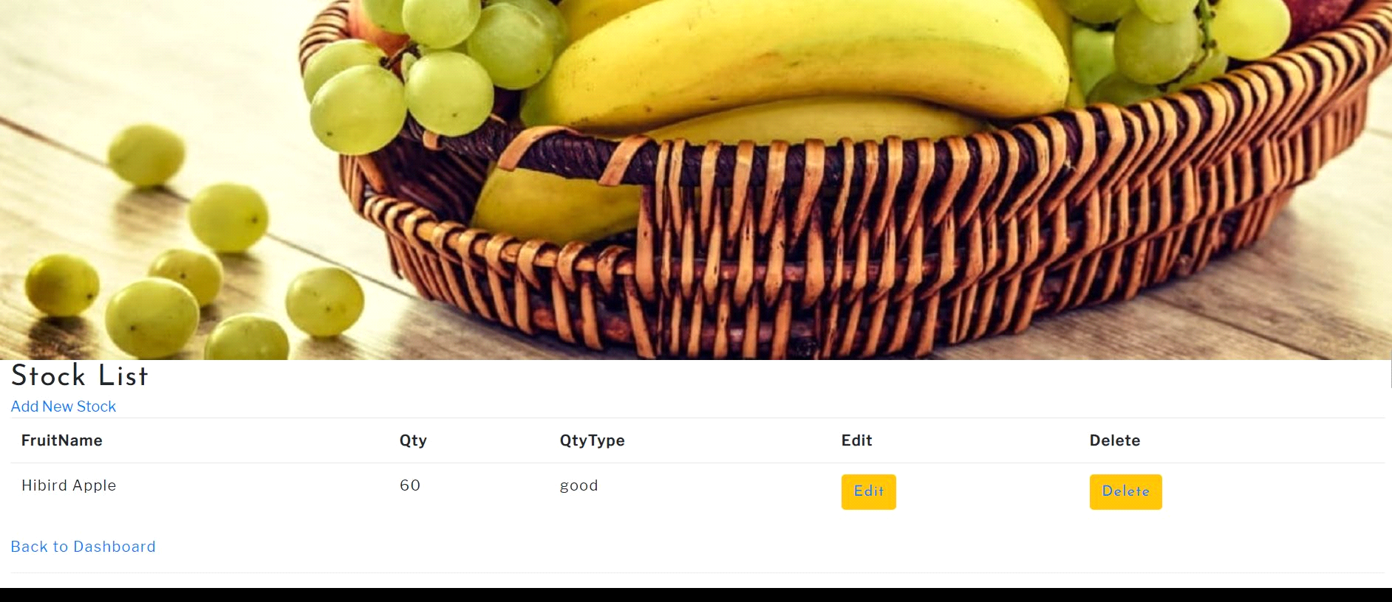

Index Page is main landing page of the website that is beautifull designed in HTML, CSS and bootstartp to create a good view for the customer as a part of attraction 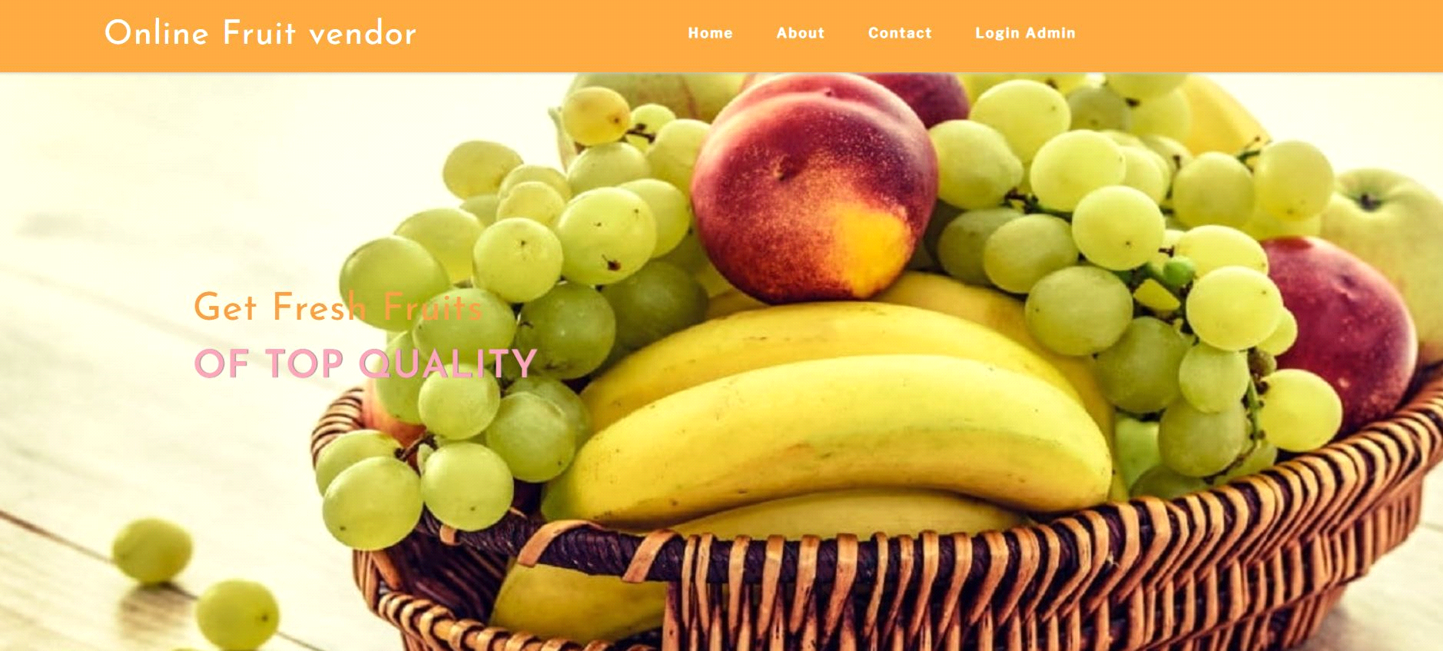

**Testing**

**Tester 1**

|  |  |  |  |  |  |  |
| --- | --- | --- | --- | --- | --- | --- |
| Tester –1 | | Answer Scale | | | | |
| No. | **Question** | **Strongly Disagree (1)** | **Disagree (2)** | **Normal (3)** | **Agree (4)** | **Strongly Agree (5)** |
| 1 | Use in Frequency |  |  |  |  |  |
| 2 | System Complication |  |  |  |  |  |
| 3 | Easy to use System |  |  |  |  |  |
| 4 | system well integrated |  |  |  |  |  |
| 5 | inconsistency in this system |  |  |  |  |  |